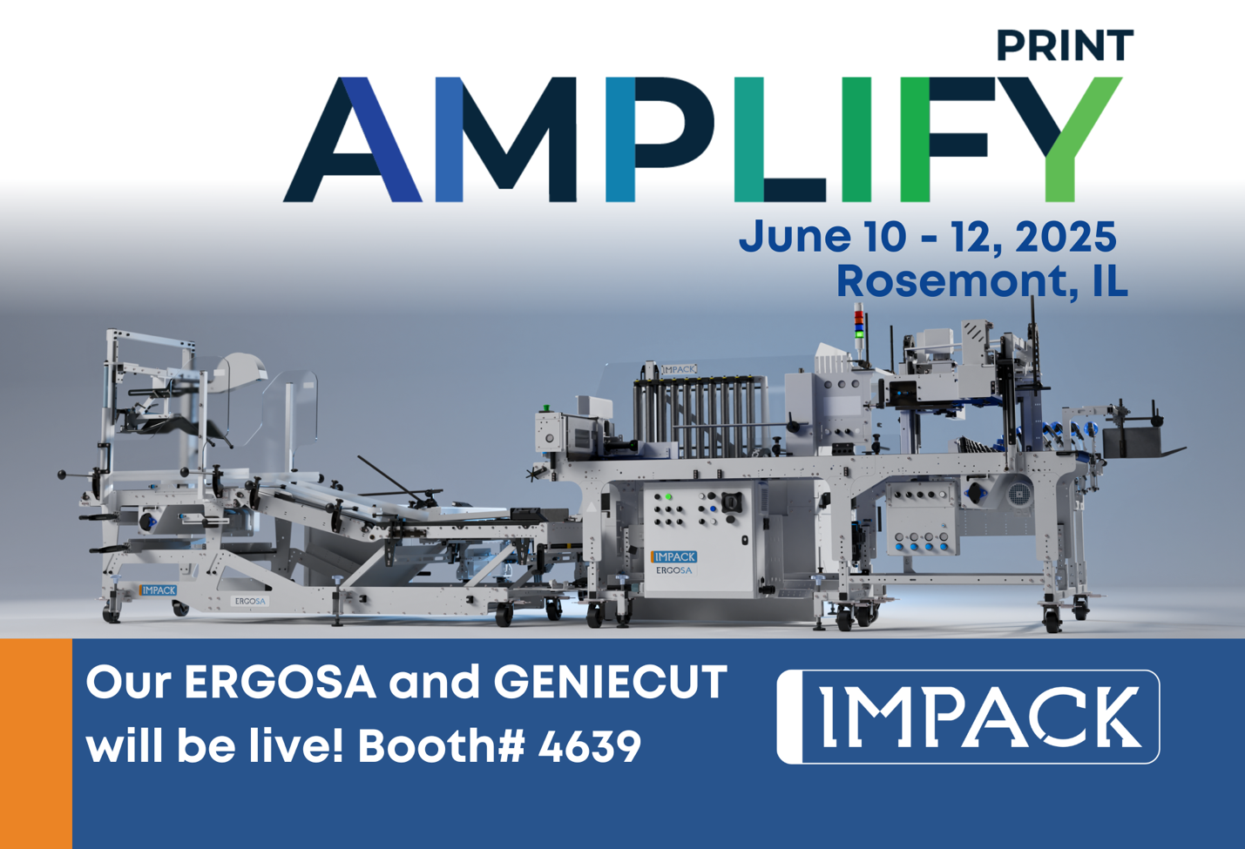

**FOR IMMEDIATE RELEASE**  
**Next-Gen Packaging Solutions: Signature Compact Folder Gluer, Leary Gluing System, IMPACK Packer, and Capital Adhesives Showcase Efficiency and Quality at Amplify Print’s Technology Zone**

May 2, 2025 | Saint Jacques, Quebec, Canada

IMPACK, W.H. Leary, and Capital Adhesives will join forces at this year’s Amplify Print June 10-12, 2025, to demonstrate cutting-edge packaging solutions in the Technology Zone, with a focus on optimizing efficiency and quality in packaging production. The fully integrated finishing line will feature the Signature Compact Folder Gluer, Leary Gluing System, IMPACK Packer, and Capital Adhesives, highlighting advanced technologies designed to boost productivity and streamline operations in the packaging industry.

“Participating in this joint demonstration aligns with our strategic focus on building strong partnerships with industry leaders,” says Mathieu Tremblay, Managing Director at IMPACK. “Demonstrating our ERGOSA system as part of an integrated setup provides a clear view of how our solutions help enhance efficiency and streamline production flow. We welcome the opportunity to engage with print professionals interested in enhancing their packaging operations through collaborative innovation.”

**Signature Compact Folder Gluer**  
The Signature Compact Folder Gluer features a carton aligner for precise carton alignment, variable-speed transfer, and an ejector system that automatically removes defects. Its compact design maximizes floor space while delivering high performance, making it an ideal solution for companies looking to increase efficiency without compromising on quality.

**W.H. Leary Gluing System**  
W.H. Leary will showcase its innovative gluing and quality assurance solutions, including the Leary Array Controller and Monet Operating Software. The demonstration will focus on the precision of cold glue and hot melt applications, using the Sempre-i Cold Glue Valve and CleanStart technology. Additionally, Leary will present the next-generation LearyVIEW Flex, a solution for inspecting glue patterns, carton flaps, handles, and skewed cartons to ensure superior quality control.

**IMPACK ERGOSA Packer**  
IMPACK will demonstrate its ERGOSA semi-automatic packer, designed for fast, efficient, and ergonomic packing of all box types. The ERGOSA features fast and easy changeovers facilitating the efficient packing of a wide range of packaging formats and sizes. Visitors will witness packing speeds double that of manual packing.

**Capital Adhesives**  
Capital Adhesives will highlight its range of cold and hot melt glues, which play a critical role in the Leary gluing system integrated into the Signature Folder Gluer line. These high-performance adhesives ensure strong, reliable bonding in the packaging process, delivering consistency and quality in every carton.

To learn more about each product and how they can improve your packaging efficiency, visit the following websites:  
[www.signaturefoldergluers.com](http://www.signaturefoldergluers.com/)[www.whleary.com](http://www.whleary.com/)[www.impack.ca](http://www.impack.ca/)[www.capitaladhesives.com](http://www.capitaladhesives.com/)

For more information, or to schedule a one-on-one meeting at the show, visit <https://impack.ca/amplify-expo-2025> or contact us directly.

**About IMPACK**

IMPACK is an engineering company that designs and manufactures automated folder-gluer peripherals for folding carton and corrugated box packaging producers. Our comprehensive product range includes in-line window patchers, pre-feeders, box turners, packers, stackers, batch inverters, as well as counting and separating modules. Our collaborative approach ensures that our clients get tailored solutions that eliminate bottlenecks and optimize workflows.

With over 20 years of experience analyzing packaging production workflows and methods, our machines are meticulously engineered based on insights gained from thousands of client interactions. We design solutions that help operators and packers to work more ergonomically and efficiently so that they can increase folder-gluer speed and ultimately production capacity.

For media inquiries, please contact:  
**Ruth Castro**

Marketing & Communications Specialist

IMPACK

+1 873-973-3000

[rcastro@impack.ca](mailto:rcastro@impack.ca)

[www.impack.ca](http://www.impack.ca/)

-----

BOX:

Cooperation

Collaboration

Partnership

--------

Image: Mathieu Tremblay



Image: ERGOSA

